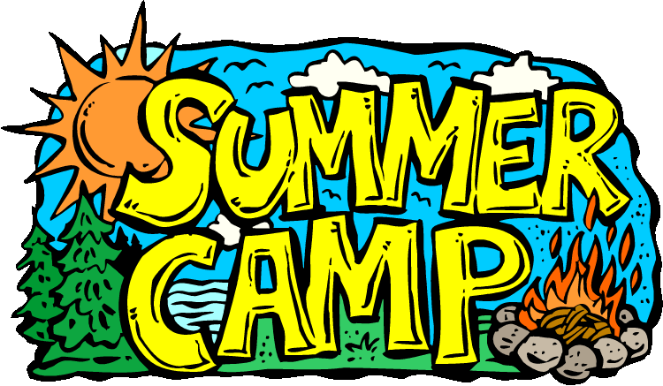
1 Cooking Class | 2 Galveston Children’s  Museum | 3 Cinemark Movie Day | 4 CLOSED | 5 Splash Day
8 Cooking Class | 9 Crocodile Encounters | 10 Cinemark Movie Day | 11  No Field Trip Due to Teacher Training | 12 Splash Day
15 Cooking Class | 16 Old MacDonald’s Farm  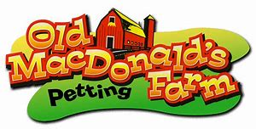 | 17 Cinemark Movie Day | 18 Armand Bayou  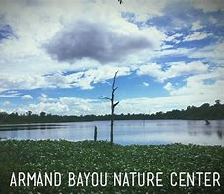 | 19 Splash Day
22 Cooking Class | 23 Kid Creations  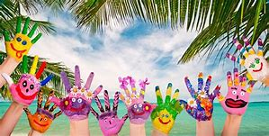 | 24 Cinemark Movie Day | 25 BBVA Compass Tour  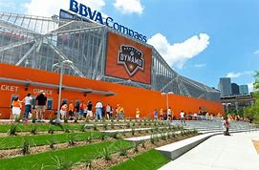 | 26 Splash Day
29 Cooking Class | 30 Moody Gardens  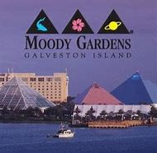 | 31 Cinemark Movie Day
July 2019

