31 HOLIDAY | 1 KID CREATION  PAINT A POT | 2 MOVIE DAY | 3 URBAN AIR  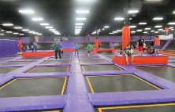 | 4 SPLASH DAY  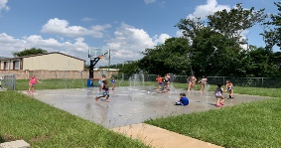
7 HMNS VISITS TWR  “INSECTS”  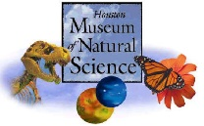 | 8 FOAM PARTY  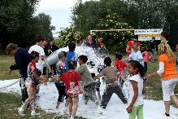 | 9 MOVIE DAY | 10 DAVE & BUSTER’S  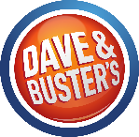 | 11 SPLASH DAY  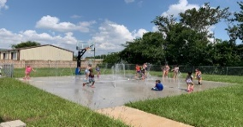
14 HMNS VISITS TWR  “NATIVE AMERICANS”  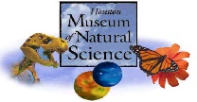 | 15 MAGICIAN | 16 MOVIE DAY | 17 CHUCK E CHEESE  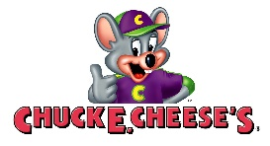 | 18 SPLASH DAY
21 HMNS VISITS TWR  “OCEAN LIFE”  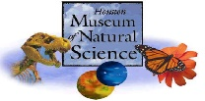 | 22 MAD SCIENCE SHOW | 23 MOVIE DAY | 24 CROCODILE ENCOUNTERS  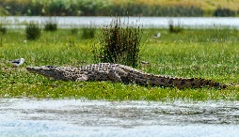 | 25 SPLASH DAY  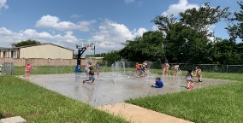
28 HMNS VISITS TWR  “PALEONTOLOGY”  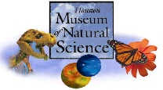 | 29 ART CAMP  SCULPTURE  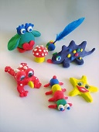 | 30 MOVIE DAY
June 2021
BECAUSE OF COVID-19, THE PLANNED ACTIVITIES MAY HAVE TO BE CHANGED WITH LITTLE TO NO NOTICE. PLEASE UNDERSTAND IF THEY DO, THIS IS OUT OF OUR CONTROL.

