August 2021
2 HMNS VISITS TWR  “CULTURAL AFRICA”  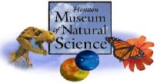 | 3 SPLASH KIDS PAINTING  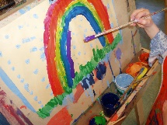 | 4 MOVIE DAY | 5 ARMAND BAYOU  “REPTILES”  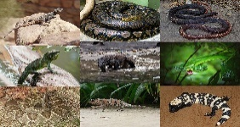 | 6 SPLASH DAY  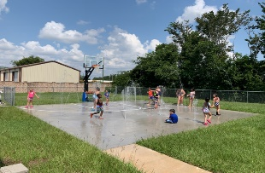
9 HMNS VISITS TWR  “BIRDS” | 10 ART CAMP  “STEAM: TINKER TIME” | 11 MOVIE DAY | 12 SPACE CENTER HOUSTON  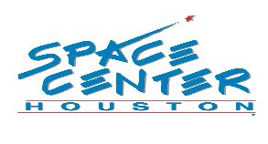 | 13 SPLASH DAY  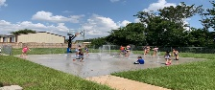  KONA ICE  SNOWCONES  FROM 2:30-3:30
16 BACK TO SCHOOL  PIZZA AND SUNDAE PARTY | 17 | 18 | 19 | 20
23 | 24 | 25 | 26 | 27
BECAUSE OF COVID-19, THE PLANNED ACTIVITIES MAY HAVE TO BE CHANGED WITH LITTLE TO NO NOTICE. PLEASE UNDERSTAND IF THEY DO, THIS IS OUT OF OUR CONTROL.

