29 Make a Difference  Monday* | 30 Stretch N Grow Visit  “All Star Sports: Soccer” | 1 Urban Easel Visit  for a painting lesson  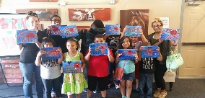 | 2 Houston Museum of  Natural Science Visit  “Insects” | 3 Closed for  Independence Day
6 Make a Difference  Monday* | 7 Stretch N Grow Visit  “All Star Sports: Soccer” | 8 Art Camp Visit  “Making a Sculpture”  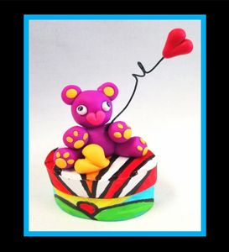 | 9 Houston Museum of  Natural Science Visit  “Native Americans”  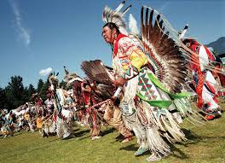 | 10 Splash Day
13 Make a Difference  Monday* | 14 Stretch N Grow Visit  “All Star Sports: Football” | 15 Mad Science Visit  “The Wacky Science Show” | 16 Houston Museum of  Natural Science Visit  “Ocean Life”  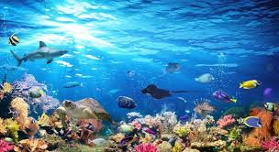 | 17 Splash Day
20 Make a Difference  Monday* | 21 Stretch N Grow Visit  “All Star Sports: Football” | 22 Bricks 4 Kidz Visit  “Lego Workshop”  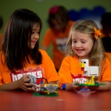 | 23 Houston Museum of  Natural Science Visit  “Paleontology”  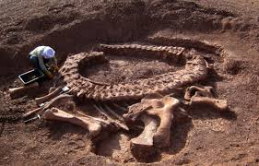 | 24 Splash Day
27 Make a Difference  Monday* | 28 Stretch N Grow Visit  “All Star Sports: Track & Field” | 29 Art Camp Visit  “Steam: Tinker Time”  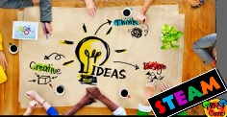 | 30 Houston Museum of  Natural Science Visit  “Texas Wildlife”  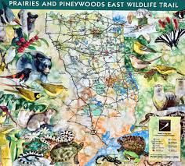 | 31 Splash Day
July 2020
BECAUSE OF COVID-19, THE PLANNED ACTIVITIES MAY HAVE TO BE CHANGED WITH LITTLE TO NO NOTICE. PLEASE UNDERSTAND IF THEY DO, THIS IS OUT OF OUR CONTROL.
*EACH MONDAY WE WILL PICK A NON-PROFIT, LEARN ABOUT THEIR MISSION AND MAKE ITEMS TO SEND THEM.

