1 Make a Difference  Monday* | 2 Stretch N Grow Visit  “All Star Sports: Baseball” | 3 Kids Creation Visit  “Paint a Pot, Plant a Flower”  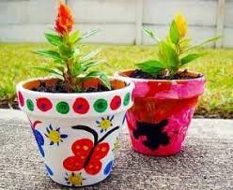 | 4 Houston Museum of  Natural Science Visit  “Ancient Egypt”  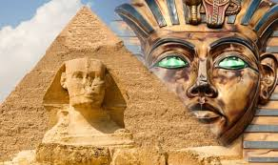 | 5 Splash Day  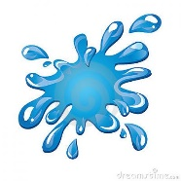
8 Make a Difference  Monday* | 9 Stretch N Grow Visit  “All Star Sports: Baseball” | 10 Kid N Play Visit  “Foam Party” | 11 Houston Museum of  Natural Science Visit  “Astronomy”  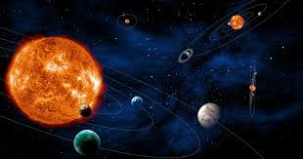 | 12 Splash Day
15 Make a Difference  Monday* | 16 Stretch N Grow Visit  “All Star Sports: Basketball” | 17 The Magic Party Visit  “Robert Berry the Magician” | 18 Houston Museum of  Natural Science Visit  “Cultural Africa”  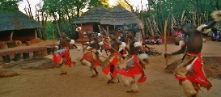 | 19 Splash Day
22 Make a Difference  Monday* | 23 Stretch N Grow Visit  “All Star Sports: Basketball” | 24 MD Anderson Visit  “Too Cool to Smoke Puppet Show”  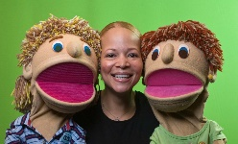 | 25 Houston Museum of  Natural Science Visit  “Birds”  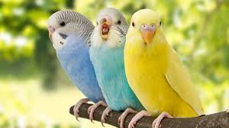 | 26 Splash Day
June 2020
BECAUSE OF COVID-19, THE PLANNED ACTIVITIES MAY HAVE TO BE CHANGED WITH LITTLE TO NO NOTICE. PLEASE UNDERSTAND IF THEY DO, THIS IS OUT OF OUR CONTROL.
*EACH MONDAY WE WILL PICK A NON-PROFIT, LEARN ABOUT THEIR MISSION AND MAKE ITEMS TO SEND THEM.

